
Chair of Metal Forming and Casting
Department of Mechanical Engineering
Technical University of Munich

Application of CNN on
Crystal Plasticity for
Material Modelling
—
Department of Aerospace Engineering
Term Paper
Betreut von/Supervisor
Lukas Martinitz
Chair of Metal Forming and Casting

Eingereicht von/Submitted by
Pradeepti Shekhar
Matriculation number - 03752122

Eingereicht am/Submitted on
20.12.2023


I hereby declare that this thesis is entirely the result of my own work except where otherwise indicated. I have only used the resources given in the list of references.
München, 20/12/2023
ABSTRACT
The Aerospace field relies heavily on structures that have excellent mechanical and thermal properties with fatigue resistance and high fracture toughness. This leads to a significant use of Anisotropic Materials including alloys and composites in the manufacturing of Aircrafts and Satellites.
Anisotropic Materials have physical properties that depend on the direction of measurement for e.g., Young’s Modulus, yield strength, creep rate, etc. Carbon Fiber-Reinforced Polymers (CFRP) are used in wings and fuselage due to their high strength to weight ratio, Kevlar has high tensile strength and is therefore used in space shuttles to protect against impact from orbital debris. Aluminium alloys are also used extensively in aeroplanes because of their high strength-to-weight ratio, corrosion resistance and low cost.
Since anisotropy is complex and the properties are crystal structure dependent, Crystal Plasticity Theory is used to understand and determine the micro-scale deformation of metals. According to Crystal plasticity theory, deformation occurs through the motion of dislocation in a slip system. This theory also provides the stress-strain relationship of the grains in a crystal.
However, determination of anisotropic properties through crystal plasticity theory requires high computational costs and effort. To combat this problem, this paper aims at determining the properties of a AA5083 polycrystal by feeding information obtained from crystal plasticity simulations in DAMASK to a Convolutional Neural Network. The ability of neural networks to understand complex relationships between features and predict the desired output with high accuracy would contribute significantly in reducing the challenges associated with crystal plasticity simulations.
The simulations were carried out by Lukas Martinitiz, Researcher at TUM and my supervisor. The CNN model was trained to predict stresses and new orientations produced due to deformation gradients applied on the Representative Volume Element (RVE), while also preserving the relative position of grains. The model was evaluated by calculating the Root Mean Squared Error (RMSE) for stresses and Mean Absolute Error (MAE) for orientations and the results were discussed. The CNN replicated the Crystal Plasticity simulation information with 2% training and validation loss and 31 MPa stress RMSE and 16% orientation MAE.

NOMENCLATURE
Abbreviations
RVE | Representative Volume Element
DAMASK | Düsseldorf Advanced Material Simulation Kit
FCC crystal | Face-Centered Cubic crystal
BCC crystal | Body-Centered Cubic crystal
HCP crystal | Hexagonal closed packed crystal
CP | Crystal Plasticity
CPFEM | Crystal Plasticity Finite Element Method
CPFFT | Crystal Plasticity Fast Fourier Transform
ML | Machine Learning
AI | Artificial Intelligence
CNN | Convolutional Neural Network
RNN | Recurring Neural Network
FNN | Feed Forward Neural Network
DNN | Deep Neural Network
FC layer | Fully Connected Layer
HDF | Hierarchical Data Format

Variables and constants
F | Deformation Tensor
$$\tilde{L}$$ | Spatial Velocity Gradient
E | Lagrangian Tensor
σ | Cauchy Stress
t | Traction
𝜏 | First Piola-Kirchoff stress
J | Jacobian of deformation
𝑆 | Second Piola-Kirchoff Stress
$$γ$$ | Deformation increase
𝐷 | Stretching
𝛺 | Spinning
$F^{p}$ | Plastic part of deformation
$$F^{*}$$ | Elastic part of the deformation gradient.
$$τ_{α}$$ | resolved shear stress
K | Elastic moduli tensor
L | Modified elastic Tensor
𝑥𝑖 | input features
𝜔𝑖 | weights
𝑏 | bias
tanh(x) | Tangent hyperbolic function of x

Contents
1 Introduction 1
1.1 Motivation of the work 1
1.2 Objective 1
1.3 Structure of the work 1
2 State of the Art 2
2.1 Polycrystal 2
2.2 Continuum mechanics 3
2.3 Large Deformation Kinematics 3
2.3.1 Strain 4
2.3.2 Stress 4
2.4 Crystal Plasticity Theory 5
2.4.1 Crystal Plasticity Kinematics 5
2.4.2 Plastic Deformation 9
2.4.3 Elasticity 9
2.4.4 Overall Constitutive Law 9
2.4.5 Application of Crystal Plasticity 10
2.5 Machine Learning 11
2.5.1 Neural Networks 11
2.5.2 Deep Neural Networks 12
2.5.3 Convolutional Neural Network 13
2.5.4 Specialized NN Architectures 14
3 Methodology 16
3.1 Data Generation 16
3.2 Data Extraction 16
3.2.1 Initialization 16
3.2.2 Data Processing Loop 16
3.2.3 Subsequent Increments 17
3.2.4 Data Storage 17
3.3 Data Pre-Processing 17
3.4 CNN Model 17
3.4.1 Dataset Handling 17
3.4.2 Neural Network Architecture 18
3.4.4 Activation function 18
3.4.5 Training and Validation 18
3.4.6 Optimization 18
3.4.7 Evaluation criteria 18
3.5 Experiments 19
3.5.1 Hyperparameter tuning 19
3.5.2 Alternative NN architectures 19
4 Results and Discussion 20
4.1 Initial Architecture 20
4.1.1 LR = 0.01, Batch Size = 128, Epochs = 10 20
4.1.2 LR = 0.005, Batch Size = 128, Epochs = 10 21
4.1.3 LR = 0.01, Batch Size = 128, Epochs = 20 22
4.2 Changing Train-Validation Data Split 23
4.2.1 LR = 0.01, Batch Size =128, Epochs = 15 23
4.2.2 LR = 0.01, Batch Size = 128, Epochs = 30 24
4.3 Addition of Max Pooling Layer 25
4.3.1 Lr = 0.01, batch size =128, Number of epochs =30 26
4.4 Addition of Dropout Layer 27
4.4.1 Lr = 0.01, batch size =128, Number of epochs =15 27
4.4.2 Lr = 0.01, batch size =128, Number of epochs =30 28
4.4 Final Model 29
4.5 Discussion 30
5 Conclusions 32
List of Figures 33
References 34

1 Introduction

Motivation of the work
Material selection is an important part of the manufacturing process. To choose the correct material, the properties of different materials need to be determined so as to find the material that best suits the criteria set forth by the application. The science of determining material properties is called Material Modelling.
A common way of modelling materials is by performing computational simulations to understand the behaviour of materials under load. However, computational simulations of crystal plasticity to determine the mechanical behaviour of anisotropic materials are expensive.
This paper aims to combine crystal plasticity theory and machine learning by using Convolutional Neural Networks to predict the mechanical behaviour of anisotropic metals. The broader goal is to contribute towards developing neural network models that can be used as a replacement for computational simulations.

Objective
Computational simulations were carried out on a 50-grain AA5083 RVE which is an aluminium-magnesium alloy (with trace amounts of chromium and manganese) commonly used in aerospace structures due to its high strength and high thermal and chemical resistance. The element was subjected to different types of loading and the information obtained through crystal plasticity simulations over the grain in DAMASK was stored in HDF5 format. The data from the DAMASK simulations contains the deformation gradient, orientations, slip resistance and stresses produced in each grain in the RVE for each time increment in each state.
The objective of this paper is to obtain useful information from the DAMASK simulations namely, deformation gradient, orientations and stresses produced for each time increment of a state such that it represents the crystal structure of the RVE. This dataset is then fed through the CNN based on PyTorch to create a model that can replicate the relationship between the deformation gradient and stresses produced due to these deformation gradients while also taking into account the orientation of each grain.

Structure of the work
The term paper is divided into 5 sections. Following the introduction, the first section, State of the Art, gives the background information related to the project which includes a basic understanding of Crystal Plasticity theory and Machine Learning. The second section, Methodology, describes the problem statement and the implementation of the experiment and the tools used. This is followed by the Results and Discussion section which contains the result of the experiment and its interpretation. At the end, there is a Conclusion section which discusses the feasibility of the experiment and possible future enhancements.

State of the Art

Polycrystal
Polycrystalline materials are solid structures comprised of numerous tiny crystals known as "grains." These grains are delineated by grain boundaries and typically exhibit random crystallographic orientations. Polycrystals are made of aggregates of single crystal grains, which make up the RVE. (1)

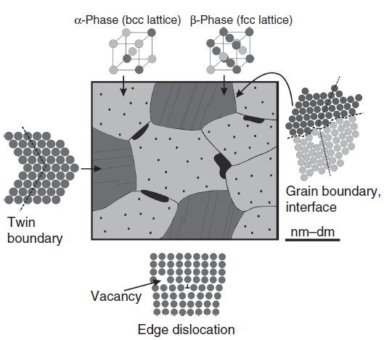
Figure 1 Schematic of a Polycrystalline metallic material. The grain boundaries act as interface between grains. The movement of grains cause vacancies and atomic defects. Adapted from Microstructure and Properties of Engineering Materials Helmut Clemens, SveaMayer, and Christina Scheu.
Some important features of a polycrystal material are:

- Grain Boundaries: These are the boundaries that exist between neighbouring grains in a polycrystalline material is referred to as a grain boundary. Within these boundaries, there are alterations in crystallographic orientation, causing disturbances in the usual atomic arrangement. The characteristics of these boundaries have the potential to impact the material's overall mechanical, thermal, and electrical properties. Grain boundaries prevent the movement of dislocations and cause a strengthening effect. (2)

- Processing and Formation: Polycrystalline materials commonly form due to manufacturing techniques like casting, sintering, or powder metallurgy. In these procedures, grains nucleate and develop autonomously, giving rise to an intricate microstructure composed of numerous grains and boundaries.

- Mechanical Properties: The mechanical properties of polycrystalline materials are significantly different from the mechanical properties of monocrystal materials. Grain boundaries oppose the movement of dislocations, thus affecting the strength, ductility, and deformation behaviour of the material. Hardness and fracture toughness are also affected by the number of grains. The grain boundaries accord higher strength and hardness to polycrystals than that of single crystals. The finer the crystal grains in polycrystals, the larger the ratio of grain boundary regions and the strength and hardness of metals and alloys. (3)

- Anisotropic Properties: Polycrystalline materials can be anisotropic, i.e., their mechanical and thermal properties may depend on the direction in which they are measured. The difference in crystallographic orientations of individual grains gives rise to anisotropy.

- Grain Size: The size of each individual grain in a polycrystalline material also affects its properties. Increased strength and hardness are observed in fine-grained materials as compared to coarse-grained materials.

Continuum mechanics
Continuum mechanics is based on the concept of a homogeneous continuum, which can be repeatedly subdivided into infinitesimal sub volumes, each of which retains the properties of the bulk material. (4)

Large Deformation Kinematics
The following derivation is adapted from Microstructure and Properties of Engineering Materials by Helmut Clemens, Svea Mayer, and Christina Scheu.
Large deformation kinematics is used to define the deformation of a material when it changes from a reference state to a deformed state. In the following figure, the vector x represents the position of a material point in the initial configuration, while the vector y(x) denotes the position of the same point in the present configuration. The displacement vector for this point is expressed as u(x) = y(x) - x. The velocity vector for the material point is given by v(x) = du/dt, and the current configuration's surface traction distribution is denoted by t.
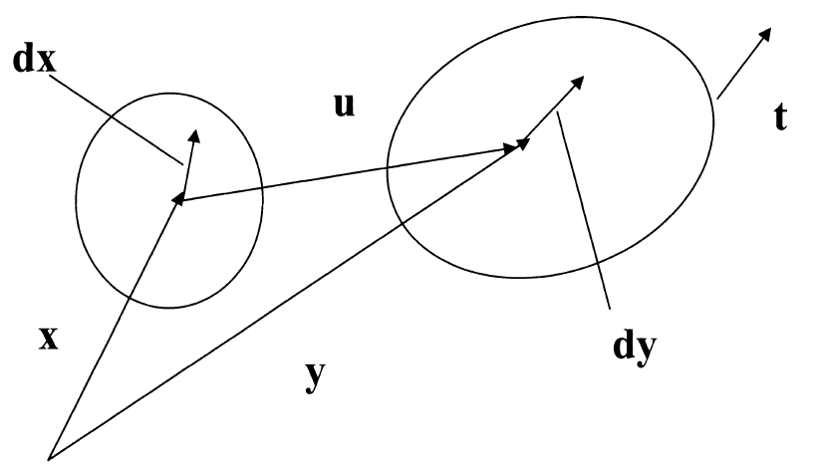
Figure 2 Finite Deformation Kinematics adapted from Microstructure and Properties of Engineering Materials Helmut Clemens, SveaMayer, and Christina Scheu.

Let us take an infinitesimal material fibre defined by dx in the reference configuration and by dy in the deformed configuration. The deformation tensor F relates the reference and current configuration by
$ⅆy=F⋅ⅆx⇔F=\frac{∂y}{∂x}=∇y⇔F_{i\dot{j}}=\frac{∂y_{i}}{∂x_{j}}=y_{ij}$ (1)
and the spatial velocity gradient is defined by
$\tilde{L}=\dot{F}⋅F^{-1}$. (2)

Strain
Consider the change in magnitude of dx due to stretching. The derivation is adapted from Microstructure and Properties of Engineering Materials by Helmut Clemens, Svea Mayer, and Christina Scheu.

$$\left|ⅆy^{2}\right|-\left|ⅆx^{2}\right|=\left(F⋅ⅆx\right)⋅\left(F⋅ⅆx\right)-ⅆx⋅ⅆx$$
$$=ⅆx⋅\left(F^{T}⋅F\right)ⅆx-ⅆx⋅ⅆx$$
$=ⅆx\left(F^{T}⋅F-I\right)⋅ⅆx$
$=2ⅆx⋅E⋅ⅆx$ (3)
Where E is the Lagrangian tensor.
$$E=\frac{1}{2}\left(F^{T}⋅F-I\right)$$ (4)
It is evident that the relationship between strain and displacement gradient is non-linear.

2.3.2 Stress
The derivation is adapted from Microstructure and Properties of Engineering Materials by Helmut Clemens, Svea Mayer, and Christina Scheu.
Cauchy stress (σ) is the force per unit area in the deformed configuration. It is defined as traction t on a surface per unit normal vector to the surface $\tilde{n}$.
$$σ=\frac{t}{\tilde{n}} ( SEQ Equation \backslash * ARABIC 5)$$
Piola- Kirchoff stresses are pseudo stresses. The first Piola-Kirchoff stress is given by
$τ=Jσ ( SEQ Equation \backslash * ARABIC 6)$
where J is the jacobian of the deformation.
The second Piola-Kirchoff stress is represented by S,
$S=F^{-1}τF^{-T}$ ($SEQ Equation \backslash * ARABIC 7)$

2.4 Crystal Plasticity Theory
The primary physical process causing plastic deformation at room temperatures involves the movement of dislocations along crystal slip systems. This dislocation motion does not lead to any overall compression or expansion of the crystal lattice, ensuring that plastic deformation maintains volume. Once the dislocation has traversed through, the lattice returns to an undistorted state.
Slip systems refer to closely packed atomic directions on similarly closely packed atomic planes. This configuration has the smallest value of Burgers vector, thus making it the most favourable direction for slip. Some basic crystal structures and major slip systems are (indicated by their Miller Indices) are as follows (5):

• FCC- AI, Cu, Ni, y-Fe- <1 1 1>{1 1 0}
• BCC-a-Fe,o-Fe,Cr,Mo-<11 0>{1 1 1}
• HCP-Mg,Zn-<0001>{1 1-1 0}
A significant consequence of crystallographic slip is the rotation of the crystal lattice, a result of the finite deformation associated with extensive dislocation flow. This phenomenon is depicted in Figure 3, where an idealized single crystal specimen with a single active slip system is subjected to tensile loading. The finite deformation during slip generates an unbalanced moment, necessitating the rotation of the specimen and, consequently, the lattice, to restore equilibrium. This rotation induces bending stresses at the supports due to the imposed constraints. In a broader context, it can be stated that lattice rotation is geometric in nature, and it does not need to occur uniformly across the entire crystal; it may be constrained in specific locations, leading to the generation of stresses.
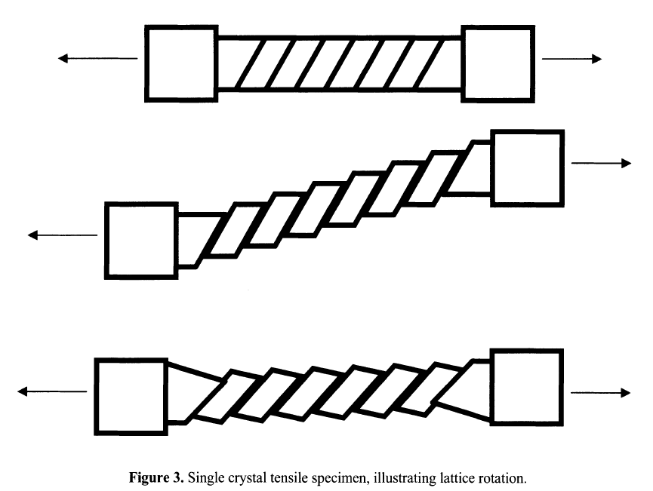
Figure 3 Lattice rotation in a single crystal tensile specimen adapted from Microstructure and Properties of Engineering Materials Helmut Clemens, SveaMayer, and Christina Scheu.

2.4.1 Crystal Plasticity Kinematics
Crystal Plasticity theory is considered a physical based theory as it is based on the behaviour of microstructures in a material. In crystal plasticity theory, flow of massive dislocation in a slip system are represented as a plastic shear strain y in a continuum sense, where the slip plane normal is represented by the unit vector m and direction of the slip by unit vector s. (5)
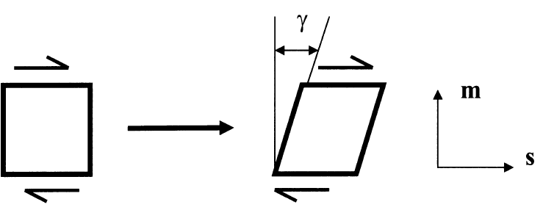
Figure 4 Plastic shear strain on a slip system adapted from Microstructure and Properties of Engineering Materials Helmut Clemens, SveaMayer, and Christina Scheu.
This plastic shear strain can be related to deformation and strain through tensorial representation. To achieve this, under the assumption of small strain kinematics, let there be a material point x within a crystal and a material fibre dx, in the reference configuration. (5)
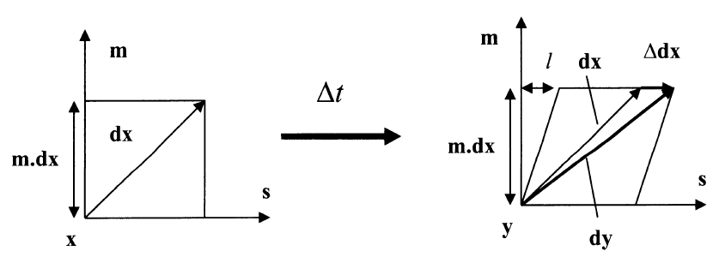
Figure 5 Kinematics of deformation of crystal adapted from Microstructure and Properties of Engineering Materials Helmut Clemens, SveaMayer, and Christina Scheu.
An increase in deformation, resulting from shear movement on a slip system by an amount Δ γ over a time Δ t, leads to the displacement of the material point at x to y. Subsequently, the fiber is now defined by dy, while the stretching and rotation of the fibre are represented by Δ dx.
The following derivation is taken from Microstructure and Properties of Engineering Materials by Helmut Clemens, Svea Mayer, and Christina Scheu.
$$\frac{l}{m⋅ⅆx}=Δγ=\dot{γ}Δt ( SEQ Equation \backslash * ARABIC 8)$$
$$l=\dot{γ}Δtm⋅ⅆx ( SEQ Equation \backslash * ARABIC 9)$$
but we know,
$l=\left|Δⅆx\right|$ ($SEQ Equation \backslash * ARABIC 10)$
$\left|ⅆx\right|=\dot{γ}Δtm⋅ⅆx$ ($SEQ Equation \backslash * ARABIC 11)$
Now,
$Δⅆ\left|Δⅆx\right|s$($SEQ Equation \backslash * ARABIC 12)$
$$Δⅆx=\dot{γ}Δts\left(m.dx\right)$$ | ($SEQ Equation \backslash * ARABIC 13)$
$$\frac{Δⅆx}{Δt}=\dot{γ}s\left(m⋅ⅆx\right)$$ | ($SEQ Equation \backslash * ARABIC 14)$
$$\lim_{Δt→0}\frac{Δⅆx}{Δt}=ⅆ\dot{x}$$ | ($SEQ Equation \backslash * ARABIC 15)$
Therefore,
$$ⅆ\dot{x}=\dot{γ}s\left(m⋅ⅆx\right)$$ | ($SEQ Equation \backslash * ARABIC 16)$

The equation can be written as
$ⅆ{\dot{x}}_{i}=\frac{∂{\dot{x}}_{i}}{∂x_{j}}ⅆx_{j}$ | ($SEQ Equation \backslash * ARABIC 17)$

Differentiating using chain rule,
$\frac{ⅆ{\dot{x}}_{i}}{ⅆx_{j}}=\frac{∂{\dot{x}}_{i}}{∂x_{j}}ⅆ{\dot{x}}_{j}=\dot{γ}s_{i}m_{j}ⅆx_{j}$ | ($SEQ Equation \backslash * ARABIC 18)$

For arbitrary $ⅆx_{j} values we have,$
$$\frac{∂{\dot{x}}_{i}}{∂x_{j}}=\dot{γ}s_{i}m_{j}$$ | ($SEQ Equation \backslash * ARABIC 19)$
The left-hand side of the equation represents velocity gradient $\tilde{L}$
$${\tilde{L}}_{ij}=\dot{γ}s_{i}m_{j}$$ | ($SEQ Equation \backslash * ARABIC 20)$

Converting this to tensor form,
$\tilde{L}=\dot{γ}sm$ | ($SEQ Equation \backslash * ARABIC 21)$

The velocity gradient gives both stretching rate and spinning rate.
The same method can be used to get the deformation of a crystal going from a deformed state $y_{t}$at time t to an increased deformed state $y_{t+Δt}$ at time $t+Δt$.
$$ⅆ\dot{y}=\dot{γ}s\left(m⋅ⅆy\right)$$ | ($SEQ Equation \backslash * ARABIC 22)$
$$ⅆ{\dot{y}}_{i}=\dot{γ}s_{i}m_{j}ⅆy_{j}$$ | ($SEQ Equation \backslash * ARABIC 23)$
$$\frac{∂{\dot{y}}_{i}}{∂y_{j}}={\tilde{L}}_{ⅈj}=\dot{γ}s_{i}m_{j}$$ | ($SEQ Equation \backslash * ARABIC 24)$
$$\tilde{L}=\dot{γ}sm$$ | ($SEQ Equation \backslash * ARABIC 25)$

where, $\tilde{L}$is the spatial velocity gradient.
According to Continuum mechanics, the deformation gradient is given by
$F=\frac{∂y}{∂x}$ | ($SEQ Equation \backslash * ARABIC 26)$
$$\tilde{L}=\frac{∂\dot{y}}{∂y}=\frac{∂\dot{y}}{∂x}\frac{∂x}{∂y}=\dot{F}⋅F^{-1}$$ | ($SEQ Equation \backslash * ARABIC 27)$

This is broken down into symmetric and non-symmetric components, stretching and spinning, respectively.
$D=\frac{1}{2}\left(\tilde{L}+{\tilde{L}}^{T}\right)$ | ($SEQ Equation \backslash * ARABIC 28)$
$$Ω=\frac{1}{2}\left(\tilde{L}-{\tilde{L}}^{T}\right)$$ | ($SEQ Equation \backslash * ARABIC 29)$
where D is strain rate (rate of deformation tensor) and Ω is the plastic spin tensor.
A single slip would be represented by
$$F=\left[\begin{matrix}1 & γ \\ 0 & 1\end{matrix}\right]⇒τ=\left[\begin{matrix}0 & \dot{γ} \\ 0 & 0\end{matrix}\right]⇒D=\left[\begin{matrix}0 & {\dot{γ}}/2 \\ {\dot{γ}}/2 & 0\end{matrix}\right], Ω= \left[\begin{matrix}0 & {\dot{γ}}/2 \\ -\left({\dot{γ}}/2\right) & 0\end{matrix}\right]$$
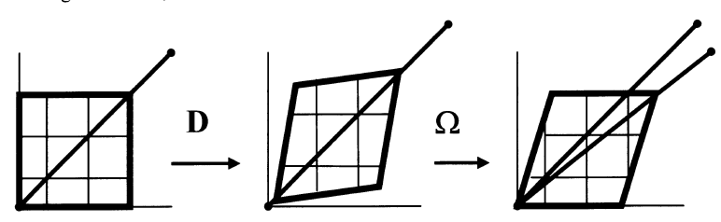
Figure 6 Kinematics of Crystal Deformation, Stretching and Spinning adapted from Microstructure and Properties of Engineering Materials Helmut Clemens, SveaMayer, and Christina Scheu.
For n slip systems with α active points
$$\tilde{L}=D+Ω_{plastic}=\sum_{α=1}^{n}{{\dot{γ}}_{a}s_{α}m_{α}}$$ | ($SEQ Equation \backslash * ARABIC 30)$

Now, plastic deformation is combined with elastic and rigid body deformation through multiplicative decomposition of the deformation gradient F,
$$F=F^{*}⋅F^{p}$$ | ($SEQ Equation \backslash * ARABIC 31)$

where, $F^{p}$ is the plastic part of deformation gradient and $F^{*}$ is the elastic part of the deformation gradient.
From this we understand that in this process, starting from the reference configuration, plastic flow induces deformation through the lattice without altering the lattice itself until an intermediate configuration is attained. Subsequently, elastic deformation and rigid body motion of the crystal structure and its enclosed material takes place, leading to the final or current configuration. It is important to note that, in reality, both types of deformation typically happen concurrently.
The second Piola- Kirchoff Stress S and the Lagrangian Strain Tensor E can be defined on the reference state.
$$S=F^{-1}τF^{-T} and E=\frac{1}{2}\left(F^{T}⋅F-I\right)$$ | ($SEQ Equation \backslash * ARABIC 32)$
Similarly, on the intermediate configuration, S* and E* can be defined as
$$S^{*}=F^{*-1}τF^{*-T} and E^{*}=\frac{1}{2}\left(F^{*T}⋅F^{*}-I\right)$$ | ($SEQ Equation \backslash * ARABIC 33)$

2.4.2 Plastic Deformation
Plasticity is a crystal property. Plasticity occurs because the slip system shear stress causes slip system shear strain in the crystal, $τ_{α}⇒{\dot{γ}}_{α}$. The movement of crystal lattice causes the slip systems to move, this deformation is described by F*. It is understood that $m_{α}$ and $s_{α}$leads to $m_{α}^{*}$ and $s_{α}^{*}$ in the current configuration, where $s_{α}^{*}=F^{*}s_{α}$ and $m_{α}^{*}=F^{*-T }m_{α}$. (5)
The resolved shear stress is given by
$τ_{a}=m_{α}^{*}⋅τ⋅s_{α}^{*}$ | ($SEQ Equation \backslash * ARABIC 34)$

2.4.3 Elasticity
Stresses produced in a crystal depend solely on the elastic deformation of the crystal. In the intermediate form, this can be represented by (5)
${\dot{S}}^{*}=K:{\dot{E}}^{*}$ | ($SEQ Equation \backslash * ARABIC 35)$
where K is the elastic moduli tensor.

2.4.4 Overall Constitutive Law
The Overall Constitutive Law can be formed on either the reference configuration or the deformed configuration. Using the reference configuration, the quantities and their time derivatives on the axes of rotation can be ignored.
After differentiating and combining the equation 32 and equation 33, the following equation is obtained
$${\dot{E}}^{*}=F^{p-T}⋅\dot{E}⋅F^{p-1}-\sum_{α=1}^{n}{{\dot{γ}}_{α}A_{α}}$$ | ($SEQ Equation \backslash * ARABIC 36)$

$$A_{α}=sym\left\{F^{*T}⋅F^{*}⋅s_{α}m_{α}\right\}$$ | ($SEQ Equation \backslash * ARABIC 37)$
Combining the stresses and differentiating,
$${\dot{S}}^{*}=F^{p}⋅\dot{S}⋅F^{pT}+2\sum_{α=1}^{n}{{\dot{γ}}_{α}B_{α}}$$ | ($SEQ Equation \backslash * ARABIC 38)$
where $B_{α}=sym\left\{s_{α}m_{α}S^{*}\right\}$
Substituting the stress and strain tensor rate into the elastic rate equation, the final equations are obtained
$$\dot{S}=L:\dot{E}-\sum_{α=1}^{n}{{\dot{γ}}_{α}x_{α}}$$ | ($SEQ Equation \backslash * ARABIC 39)$
$$X_{α}=F^{p-1}⋅R_{α}⋅F^{p-T}$$ | ($SEQ Equation \backslash * ARABIC 40)$

$$R_{α}=K:A_{α}+2B_{α}$$ | ($SEQ Equation \backslash * ARABIC 41)$
where L is the modified elastic moduli tensor.

2.4.5 Application of Crystal Plasticity

2.4.5.1 Microscale Approach
The abovementioned Crystal plasticity theory can be used in Finite Element analysis to observe and study deformation in monocrystals and polycrystals at microscale. This field of study is called Crystal Plasticity Finite Element method (CPFE).
CPFE has been used to understand the anisotropic behaviour of a commercially pure Titanium Grade 1 sheet upon different strain paths by Takayuki Hama, et al. (6) The study delved into the understanding the mechanism of anisotropic deformation, with a specific emphasis on understanding the influence of twinning activity in plastic deformation. The research showed that twinning activity played a crucial role in shaping certain features, including anisotropies in the Lankford value and work hardening during compression, as well as tension-compression asymmetries in the stress-strain curves along the rolling direction. Furthermore, the detwinning activity was found to impact stress-strain curves during reverse loading, particularly in the rolling direction.
Preitang Wei, et al., studied the Anisotropic Plastic Behaviour in High Pressure Torsion of an Aluminium Single Crystal by using CPFE method. (7) They observed the changes in crystallographic orientation along the tangential direction to predict the resulting lattice rotation and slip trace. The results of the simulation indicated that the anisotropic plastic deformation observed in HPT is attributed to variations in the activation of slip systems, including dominant slip and multiple slips.

2.4.5.2 Macroscale Approach
CP is used to develop constitutive model of polycrystal aggregates. It is used to predict the deformations caused by changes in alignment of crystal lattices, from random orientations in a reference state to well-formed orientations in the deformed state. These deformations lead to anisotropic behaviour in the material at macroscopic level.
Takayuki Otsuka, et al, used CP with Fast Fourier Transform scheme to solve transformation plasticity and analyse texture development by deformation. (8) FFT was used instead of FEM because it uses significantly less computer resources to perform mathematical operations while also being capable of large-scale analyses The results showed that when the strain rate sensitivity exponent (m-value) is smaller, then the strain rate dependency is smaller, which is the characteristic of constitutive law.

2.4.5.3 Multiscale Approach
The multiscale approach combines molecular dynamics and CP theory. Pandong Lin, et al, (9) used atomic scale parameters to introduce absorption probability in the crystal plasticity framework. The mechanical behaviour of irradiated body-center-cubic (BCC) AA5083 steel was analysed using the equations for partial- and full-absorption dislocation loops. The results showed that irradiation caused an increase in movable dislocations while obstructing the decrease of immovable dislocations.
Ilona Frankenreiter, et al, (10) developed a computationally efficient two-scale hybrid model by combining a macroscopic model with crystal reorientation mechanisms, which causes anisotropies at the macroscale which are texture based. The microstructural bridging is established through definitions of macroscopic structural tensors based on homogenization, taking into consideration the changes in texture of orientation.

2.5 Machine Learning
Machine learning (ML) is a field within artificial intelligence (AI), that involves development of algorithms and models for data-driven prediction and decision-making, without any explicit programming. The fundamental goal of ML is to enable systems to iteratively enhance their performance on specific tasks through experiential learning. (11)
Machine learning is generally categorised into different learning paradigms. Supervised learning involves training algorithms on labeled datasets, where each input corresponds to a specific output. This enables the model to learn the mapping of inputs to outputs and make predictions on unseen data. In contrast, unsupervised learning tasks algorithms with learning patterns or relationships within unlabeled data, including clustering and dimensionality reduction. Semi-supervised learning uses datasets containing both labelled and unlabelled examples, combining the strengths of both paradigms. Reinforcement learning introduces an agent interacting with an environment, learning to make decisions through feedback in the form of rewards or penalties.
The usual workflow of machine learning starts with data collection, with a focus on representative datasets aligned with specific problem domains. That is followed by data pre-processing: cleaning, transformation, and preparation for effective training. The model undergoes training, adjusting its parameters to learn patterns or relationships within the data. The model is then evaluated by testing on new, unseen data to determine its generalization capabilities. Metrics, spanning accuracy to precision and recall, furnish quantitative assessments of the model's performance.
There exists a vast spectrum of algorithms and techniques within machine learning, each tailored to specific tasks and data characteristics. Conventional approaches include linear regression, decision trees, and support vector machines. With the ever-increasing popularity of deep learning, neural networks with multiple layers have proven highly effective in complex tasks such as image and speech recognition. The dynamic nature of the field is evident in the continual evolution of algorithms, with ongoing research and innovation propelling machine learning into new applications and domains. (12)
Nevertheless, the application of machine learning is not without challenges. Overfitting is a common problem when a model becomes overly attuned to the training data, and thus not able to generalize to new instances. Bias and fairness concerns underscore the need to address inherent biases in training data, preventing the perpetuation of discrimination in algorithmic decision-making. Interpretability is also a critical aspect, particularly in sensitive domains such as healthcare and finance, necessitating a comprehensive understanding of how a model arrives at its decisions. (11)

2.5.1 Neural Networks
A neural network model is made up of interconnected artificial neurons arranged in layers, encompassing an input layer, one or more hidden layers, and an output layer. (13)
The connections between nodes, characterized by adjustable weights, undergo iterative learning during training. This process, commonly referred to as backpropagation, is the adjustment of weights based on input data and target outputs, leading to the neural network's acquisition of patterns and relationships within the data.
The training for neural networks often required a considerable volume of labeled data and computational resources. To overcome these issues, transfer learning has emerged as a pragmatic approach, involving the adaptation of pre-trained neural networks for new tasks. Ongoing advancements in neural network architectures, optimization algorithms, and hardware acceleration contribute to their heightened efficacy in domains such as image recognition, natural language processing, and speech recognition. (11)

2.5.2 Deep Neural Networks
Deep Neural Networks (DNN) are a category of neural networks characterized by their depth, meaning they have multiple layers of interconnected nodes or neurons. These multiple hidden layers allowing the network to learn hierarchical representations of the input data. (13)
Noteworthy attributes of deep neural networks include the following:

2.5.2.1 General Architecture
Input Layer: The initial layer that receives the input data.
Hidden Layers: Multiple layers progressively extract hierarchical features from the input data. Each layer comprises interconnected nodes, contributing to the network's depth.
Output Layer: The terminal layer responsible for generating the network's prediction or classification.

2.5.2.2 Training
DNNs commonly undergo training via supervised learning, wherein they learn to map input data to corresponding output labels. Training involves the iterative adjustment of weights between nodes to minimize a designated loss function through optimization methodologies such as gradient descent.
Backpropagation is a fundamental supervised learning algorithm. Involves a forward pass to compute predictions, and a backward pass to calculate gradients, and iterative weight updates to minimize the difference between predicted and actual outputs. (13)

2.5.2.3 Activation Functions
Activation functions introduce non-linearities to the model, enabling DNNs to learn more complicated relationships. Prominent activation functions include Rectified Linear Unit (ReLU), sigmoid, and hyperbolic tangent (tanh). (13)

2.5.2.4 Common Types of Deep Neural Network
Feedforward Neural Networks (FNNs): The foundational form of deep neural networks, where information flows linearly from input to output without feedback loops.
Convolutional Neural Networks (CNNs): Tailored for processing grid-like data, particularly images, CNNs employ convolutional layers to capture spatial hierarchies and mitigate the need for manual feature engineering.
Recurrent Neural Networks (RNNs): Suited for sequential data, RNNs use recurrent connections to capture temporal dependencies. Variants such as Long Short-Term Memory (LSTM) and Gated Recurrent Unit (GRU) address challenges like vanishing gradients in conventional RNNs.

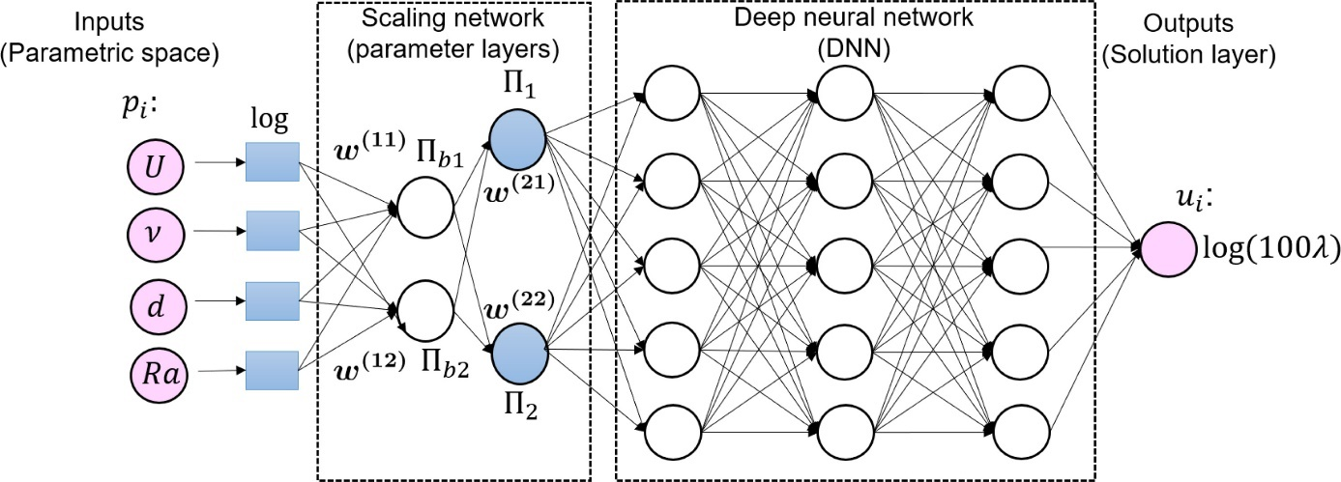
Figure 7 Architecture of Typical DNN adapted from https://www.sciencedirect.com/science/article/pii/S004578252030637X

2.5.3 Convolutional Neural Network
Convolutional Neural Networks or CNNs, are a specialized type of neural network designed for handling data with a recognizable grid-like structure. It is commonly used with image data, conceptualized as a two-dimensional grid of pixels. However, this grid topology is also applicable to various data types, such as natural language or time-series data, represented as a one-dimensional grid with samples at regular intervals. (13)

2.5.3.1 Convolution Operation
In Mathematics, convolution of a function f and function g is a function that defines how the shape of the function f changes with the function g. The convolution of f and g is written as f∗g, denoting the convolution operator with the symbol ∗.
$$\left(f*g\right)t≔-\int_{∞}^{∞}{f\left(τ\right)g\left(t-τ\right)ⅆτ}$$ | ($SEQ Equation \backslash * ARABIC 42)$
Convolution involves utilizing the kernel, which is a small matrix representing weights for transforming input data. This kernel moves across the input, performing element-wise multiplication with local regions and summing the results to generate a singular value. The output feature map is then formed, indicating the presence of specific patterns in the input.
The convolution operation encourages parameter sharing, employing the same weights throughout the input for consistent local pattern extraction. Moreover, convolutional layers demonstrate local receptive fields and translation invariance, emphasizing small, spatially local features and recognizing patterns regardless of their position.
In CNNs, multiple convolutional layers are often stacked to progressively extract hierarchical features, making this operation fundamental for tasks like image recognition and object detection.
This work uses 3D convolutions, which work in a similar manner as described above, but with 3 dimensional kernels convolving over 3-dimensional input data.

2.5.3.2 General Architecture
CNN is usually made of three fundamental layers: convolutional layers, pooling layers, and fully-connected (FC) layers. Stacking these layers results in the formation of a complete CNN architecture. (13)
Beyond these core layers, two additional significant parameters are employed: the dropout layer and the activation function.
- Input Layer: Receives the input data, typically in the form of images with height, width, and channels.
- Convolutional Layers: Applies convolution operations using learnable filters to detect features in the input.
- Pooling Layers: Reduces spatial dimensions through down-sampling or aggregation, often using max pooling.
- Flattening: Converts multi-dimensional output from previous layers into a one-dimensional vector before passing to fully connected layers.
- Fully Connected Layers: Connects each neuron in a layer to every neuron in the next layer, responsible for making predictions.
- Output Layer: Produces the network's final output, typically class probabilities for tasks like image classification.
- Dropout Layers: Sometimes added to prevent overfitting by randomly dropping neurons during training.
- Batch Normalization: Normalizes inputs of a layer to improve training stability and speed.

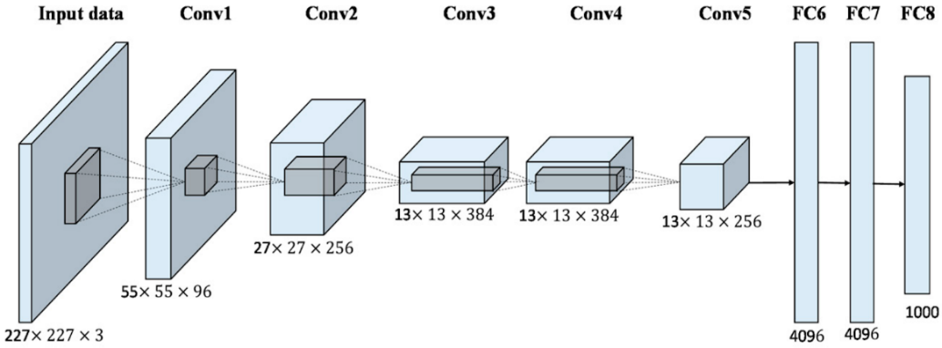
Figure 8 Architecture of AlexNet, used for image recognition and classification adapted from https://papers.nips.cc/paper_files/paper/2012/hash/c399862d3b9d6b76c8436e924a68c45b-Abstract.html
This work aims to model the problem as a regression problem, so the fully connected and flattening will not be used.

2.5.4 Specialized NN Architectures
- Encoder-Decoder networks: These networks are comprised of an encoder that is responsible for capturing and compressing input information through multiple convolutional layers, often reducing spatial dimensions, and a decoder that reconstructs the output from the encoded representation, typically using upsampling operations and convolutional layers. (14)
- Res-Net: The main characteristic here are skip-connections, wherein a previous network input is fed directly to later layers, allowing the training of very deep networks. (15)
- U-Net: It has an encoder-decoder style architecture, with the novel characteristic being encoder output vectors concatenated with vectors in the decoder. (16)
An Encoder-decoder style architecture was used for this work, partially inspired by a recent work that applied encoder-decoder networks for crystal plasticity. (14)

  - Machine Learning and Material Modelling
The use of neural networks to model anisotropy in multiscale models is an area of active research in materials science and engineering. Multiscale models are important for accurately capturing the behaviour of anisotropic materials, as they can account for the complex microstructures and physical mechanisms that give rise to anisotropy.
One approach to using neural networks in multiscale modelling is to develop hybrid models that combine atomistic or molecular dynamics simulations with continuum models. Researchers have used datasets obtained from molecular dynamics simulations to train ANNs that can approximate explicit state functions, such as the elastic stress–strain relation (tensor equation of state), the dislocation nucleation threshold, the void nucleation threshold and the beginning of bcc transformation. (17)
Another approach is to use neural networks to develop surrogate models that can replace more computationally expensive models, such as finite element models. GNN Surrogate models can be trained to predict the grain-scale elastic response of polycrystalline metallic alloys and can provide accurate predictions at a fraction of the computational cost of traditional models. (18)
Additionally, researchers are exploring the use of neural networks to develop data-driven models that can capture the anisotropic behaviour of materials at different length scales. For example, researchers have used neural networks to predict the mechanical properties of polycrystalline materials based on the crystallographic orientations of the individual grains, and have shown that these predictions can be used to develop accurate multiscale models. (19)
Overall, the use of neural networks in multiscale modelling of anisotropy is a rapidly developing area of research, and has the potential to greatly improve our understanding of the behaviour of anisotropic materials in various applications.

3 Methodology
The integration of machine learning into crystal plasticity models is particularly advantageous for the modelling of anisotropic materials. Traditional crystal plasticity models demand a deep understanding of intricate crystallographic orientations and material behaviours, often requiring extensive calibration. ML revolutionizes this process by using large datasets, allowing the model to autonomously learn complex patterns without the need for complex manual calibration.
It is a data-driven approach that enhances predictive accuracy while also addressing the computational complexity associated with anisotropic material simulations. It efficiently captures nonlinear responses and adapts to diverse material behaviours. Furthermore, the transferability of machine learning models across similar materials streamlines the modelling process and enables more versatile applications.
Due to the challenges associated with computational simulation of crystal plasticity, this paper investigates the application of CNNs in material modelling to achieve similar results as crystal plasticity simulations. 3D convolutions are chosen as the basic block, as they capture the intrinsic structure of the cells and retain the relative ordering of grains in the cell as they undergo the deformations.

3.1 Data Generation
This study employed DAMASK (Düsseldorf Advanced Material Simulation Kit) (20), a simulation too for modelling crystal plasticity on multiscale level, to investigate the mechanical behaviour of a Face-Centred Cubic (FCC) 50-grain AA5083 RVE. A comprehensive set of 245 simulations were conducted, each capturing distinct states of the crystal undergoing various loading conditions. The simulations span 100 timesteps, providing a detailed temporal evolution of the crystal's response to diverse loading scenarios. The output of each simulation was stored in Hierarchical Data Format (HDF5) files, encompassing critical information such as phases, homogenization data, and the applied material model, along with geometric attributes.
During the simulation the RVE was divided into a 16x16x16 cellular structure, where each cell is associated with a grain and contains its properties which includes deformation gradient, orientations and stresses. Therefore, there are 4096 cells and 4913 nodes encasing 50 grains.

3.2 Data Extraction
To extract meaningful information from DAMASK simulation results, a custom Python script was developed. The script utilizes the h5py library to interact with HDF5 files and leverages NumPy for efficient numerical operations.

3.2.1 Initialization
The simulation results are stored in a set of HDF5 files, each corresponding to a specific increment of the simulation. The script initializes matrices to store deformations, stresses, and orientations for further processing.

3.2.2 Data Processing Loop
The script iterates through each HDF5 file, processing increments sequentially. For the first increment (key == "increment_0"), unique orientations are computed and arranged. Grain indices are assigned based on these unique orientations, and initial orientations are averaged for each grain. It is worth noting that these unique orientations are in the quaternion form and the quaternion averaging is done to obtain the average of different orientations of the same grain in subsequent increments.

3.2.3 Subsequent Increments
For subsequent increments, the script computes average deformations, stresses, and orientations for each grain and assigns this information to all the cells associated with this grain. Processed data, including deformations per grain, stresses per grain, and new orientations per grain, is stored in a new HDF5 file under different groups named "increment_0," "increment_1," and so on. The data is extracted while also preserving the original structure of the grain.

3.2.4 Data Storage
The processed data is stored in a new HDF5 file named "extracted_data.h5," which serves as the consolidated dataset for further analysis. The extracted data consists of 24500 increments, each increment containing a 16x16x16 cellular cube, with each cell holding the information about the properties of the grain assigned to it.

3.3 Data Pre-Processing
Data scaling is the process of reducing the range of data to a desired range so as to prevent a feature from dominating the algorithm.
The 5D array of deformation gradient (16,16,16,3,3) and 5D array of orientations (16,16,16,1,4) act as input to the model and the 5D array of stresses produced to deformation gradient (16,16,16,3,3) and 5D array of new orientations due to deformation gradient (16,16,16,1,4) act as the output to the model.
The data obtained from simulation has large differences in magnitude. Deformation gradient has a magnitude of around ${10}^{-20}$ while the stresses have a magnitude of around ${10}^{10}$. Such a large difference in magnitudes made data scaling necessary. To overcome this, stresses were converted to MPa by dividing them by ${10}^{6}$ and then scaled to a range of (-1,1) using the Min Max scaler.
The Min Max scalar reduces the range of the dataset while also preserving the relationships between different features and preserving the order of the dataset.

3.4 CNN Model
Convolutional Neural Network was used in this study to replicate the behaviour of crystal plasticity due to their ability to capture spatial relationships, extract local features, and handle complex, grid-like data representations.

3.4.1 Dataset Handling
A small chunk of the dataset is separated and not used for training. This is done to find out how the model will perform on unseen dataset.
The dataset is first shuffled and then split into training, validation and test data set. The first 80% of the data is used for training. The next 10% of the dataset is used for validation and the remaining 10% for testing. The validation dataset tracks the performance of the model parameters and is used to tune the hyperparameters so as to reach a model with the best performance. The test dataset is used to test the final model fitted on the training dataset.

3.4.2 Neural Network Architecture
The deformation gradient dataset and stresses dataset is reshaped from (16,16,16,3,3) to (16,6,16,9). Therefore, each element of the deformation gradient and stresses arrays acts as a channel. The old and new orientations have a shape of (16,16,16,4) where each orientation element acts as a channel.
The deformation gradient and old orientations are combined to form a 16x16x16 cube with 13 channels. Similarly, for the output, stresses and new orientations were combined to obtain a 16x16x16 cube with 13 channels.
As given, there are 24500 cubes obtained from 245 files each having 100 increments. These cubes are fed to the network one by one. The network has 7 consecutive convolution blocks.. A standard convolution block consists of (CNN -> Batch normalization -> tanh). This encoder-decoder style architecture is inspired (14). Other variations are described in the experiments that use max pooling, transpose convolutions, and dropout.

3.4.4 Activation function
The activation function used in this network, is tanh. The tangent hyperbolic function is calculated by the following equation.
$$\tanh\left(x\right)=\frac{e^{x}-ⅇ^{-x}}{ⅇ^{x}+e^{-x}}$$ | ($SEQ Equation \backslash * ARABIC 43)$
The activation function is activated after batch normalization in each convolution block.

3.4.5 Training and Validation
The training loop is fed with deformation and orientation. After the forward pass, the model returns predicted values of stress and orientation.
The model has 10 epochs which is the number of times the dataset is fed to the model for training. At the end of each epoch, validation loss, stress RMSE and orientation MAE were calculated. At the end of training, test loss, stress RMSE and orientation MAE were calculated for the test dataset.

3.4.6 Optimization
For optimization, the Adam optimization algorithm with default parameters was employed, representing a stochastic gradient descent technique that relies on adaptively estimating both first-order and second-order moments. (21) It is used to update the weights of the network. Weight decay was set to 0.001 which is the hyperparameter for L2-regularization.
Learning rate of the algorithm was initially set at 0.01. An exponential learning rate decay (gamma 0.9) is used which reduces the learning rate after each epoch.

3.4.7 Evaluation criteria
For the loss function, The Mean Squared Error is calculated over the entire output consisting of stresses and new orientations.
$$MSE=\frac{1}{n}\sum_{i=1}^{n}{{\left(Y_{i}-{\hat{Y}}_{i}\right)}^{2}}$$ | ($SEQ Equation \backslash * ARABIC 44)$
n = number of data points
$Y_{i}$ = observed values
${\hat{Y}}_{i}$ = predicted values
For the stresses, Root Mean Square Error (RMSE) is calculated on the test dataset and for orientations Mean Absolute Error (MAE) is calculated on the test dataset
$$RMSE=\sqrt{\frac{\sum_{i=1}^{N}{{\left(x_{i}-{\hat{x}}_{i}\right)}^{2}}}{N}}$$  i = variable i  N = number of data points  $x_{i}$ = actual observations  ${\hat{x}}_{i}$ = estimated observations | ($SEQ Equation \backslash * ARABIC 45)$
$$MAE=\frac{\sum_{i=1}^{n}{\left|y_{i}-x_{i}\right|}}{n}$$  $y_{i}$=prediction  $$x_{i}=true value$$  n =total number of data points | ($SEQ Equation \backslash * ARABIC 46)$

3.5 Experiments

3.5.1 Hyperparameter tuning
The hyperparameters of the model were changed and the changes in performance were observed.
The learning rate determines the speed of learning the model. Smaller learning rate leads to smaller change in weights, thus requiring more epochs.
Learning rates used - 0.01, 0.005
Batch size determines the size of the chunk of data that is fed to the model in each iteration. A large batch size means the model will have large gradient updates. This can lead to the model not learning well form individual data points.
Batch sizes used- 128
The number of epochs is the number of times the training dataset will go through the network. A small epoch size could lead to the network not learning the model well, while too many epochs can lead to overfitting.
Number of epochs used- 10, 15, 20, 30

3.5.2 Alternative NN architectures
Initially the network had 7 convolutional layers, with the first 6 layers followed by batch normalization and tanh layers. The initial model did not have any Max Pooling Layers, dropout layers and fully connected layer. However, the performance of the network was not optimum.
The network was experimented with by adding max pooling and transpose convolution layers first and then adding drop out layers while removing batch normalization layer. The performance of each variant of the network was noted and studied.

4 Results and Discussion
The results of the experiments are presented in this section.

4.1 Initial Architecture
The initial architecture involved a neural network with 7 convolutional blocks, consisting of a 3D convolution followed by a batch normalization layer after each convolution block. This model was run on different hyperparameters, the results of which are shown here:

4.1.1 LR = 0.01, Batch Size = 128, Epochs = 10
Losses | Validation Dataset | Test Dataset
Total loss | 0.02061 | 0.02051
Stress RMSE | 41.0062 | 40.8602
Orientations MAE | 0.1118 | 0.1121
Table 1 Comparison of between Validation and Test dataset Loss for LR = 0.01, Batch Size = 128, Epochs = 10
For the validation dataset, the total loss was 0.0206, the stress RMSE loss was 41.0062 MPa and the orientation MAE loss was 0.1119. For the test dataset, the total loss was 0.0205, the stress RMSE loss was 40.8603 MPa and the orientation MAE loss was 0.1122.
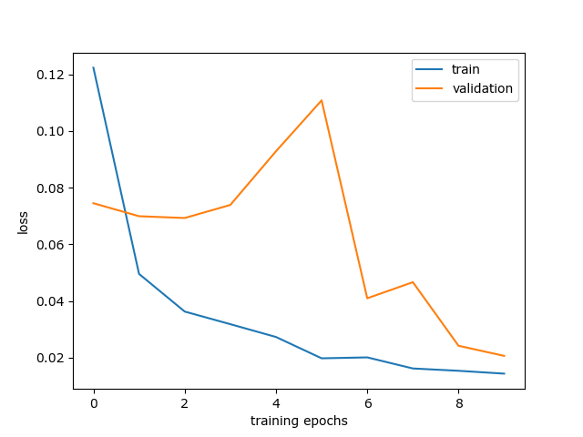
Figure 9 Training loss and Validation loss for LR = 0.01, Batch Size = 128, Epochs = 10
Figure 9, shows that the training loss decrease with epochs and so did validation loss. However, validation loss has spikes in it, indicating that the network is not stable. The hyper parameters were changed (in following sections) to improve the performance.
Figure 10 shows that both stresses RMSE and orientation MAE decrease over time however, as reflected by Figure 9, the model is not stable and the error is increasing unpredictably.

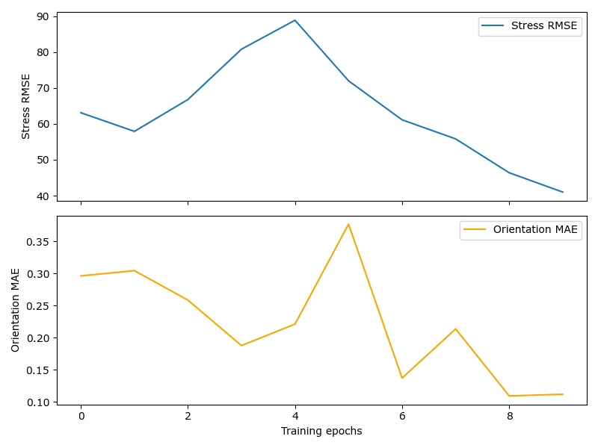
Figure 10 Stresses RMSE and Orientation MAE for LR = 0.01, Batch Size = 128, Epochs = 10

4.1.2 LR = 0.005, Batch Size = 128, Epochs = 10
Losses | Validation Dataset | Test Dataset
Total loss | 0.04170 | 0.04092
Stress RMSE | 53.3234 | 52.55547
Orientations MAE | 0.2031 | 0.2027
Table 2 Comparison between Validation and Test dataset Loss for LR = 0.005, Batch Size = 128, Epochs = 10
Table 2 shows that for the validation dataset, the total loss was 0.0417, the stress RMSE loss was 53.323 MPa and the orientation MAE loss was 0.2032. For the test dataset, the total loss was 0.04092, the stress RMSE loss was 52.5554 MPa and the orientation MAE loss was 0.2027. Since the stress RMSE loss has increased significantly and the total loss and orientation MAE have increased too, a smaller learning rate did not help.
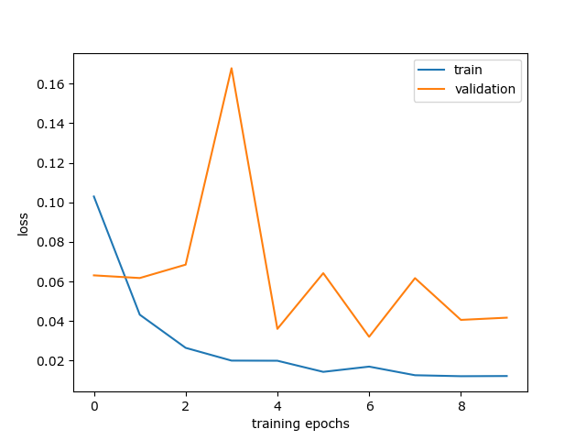
Figure 11 Training loss and Validation loss for LR = 0.005, Batch Size = 128, Epochs = 10
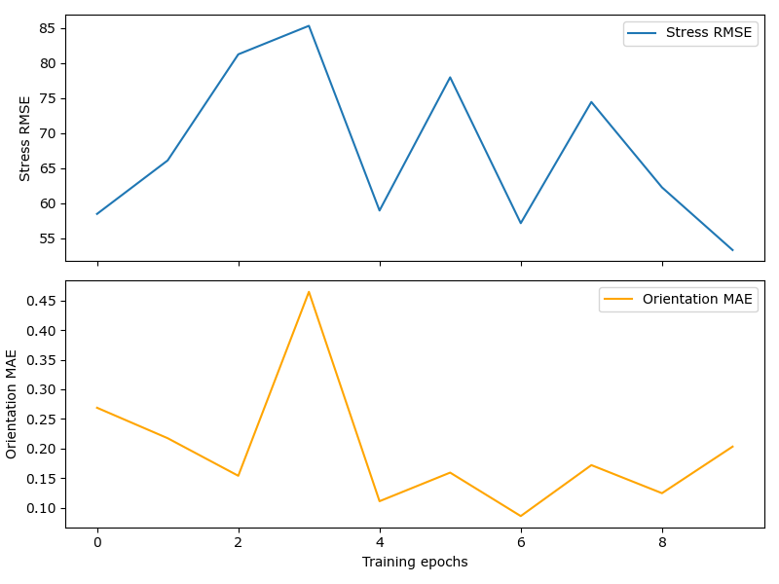
Figure 12 Stresses RMSE and Orientation MAE for LR = 0.005, Batch Size = 128, Epochs = 10
Figure 11, shows that the training loss decrease with epochs but the validation loss has not improved and there has been no decrease in spikes too. Figure 12 shows that both stresses RMSE and orientation MAE decrease over time however there is a very large spike that makes the model unusable.

4.1.3 LR = 0.01, Batch Size = 128, Epochs = 20
Losses | Validation Dataset | Test Dataset
Total loss | 0.02171 | 0.02140
Stress RMSE | 44.7528 | 44.3849
Orientations MAE | 0.08645 | 0.08671
Table 3 Comparison between Validation and Test dataset Loss for LR = 0.01, Batch Size = 128, Epochs = 20
In Table 3, for the validation dataset, the total loss was 0.0217, the stress RMSE loss was 44.7528 MPa and the orientation MAE loss was 0.0864 and for the test dataset, the total loss was 0.02141, stress RMSE loss was 44.6849 MPa and the orientation MAE loss was 0.0867. Since the orientation MAE have decreased but the total loss and stress RMSE has not changed, the increase in epochs cannot solely improve the model.
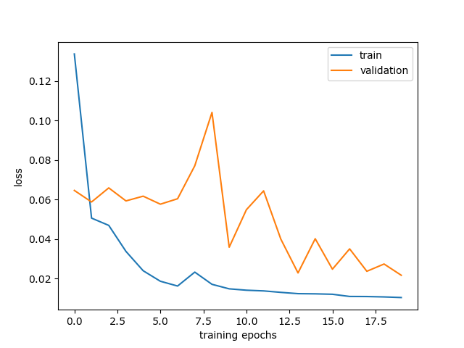
Figure 13 Training loss and Validation loss for LR = 0.01, Batch Size = 128, Epochs = 20

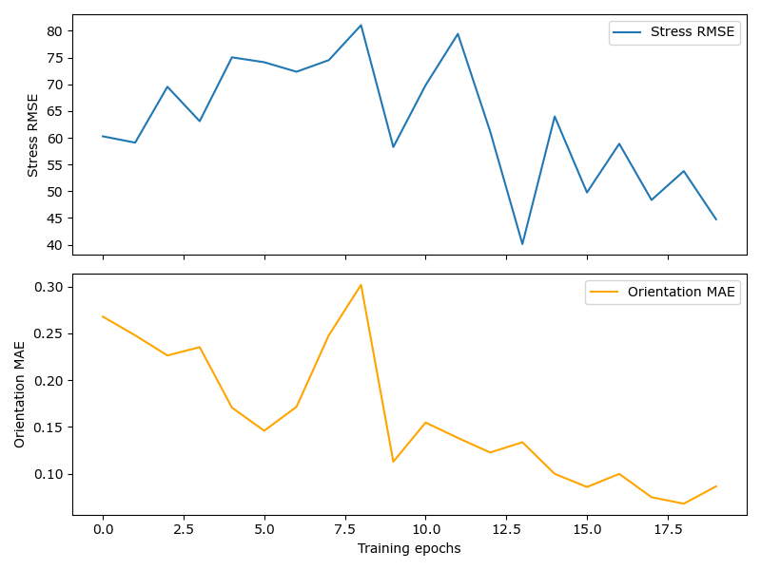
Figure 14 Stresses RMSE and Orientation MAE for LR = 0.01, Batch Size = 128, Epochs = 20
Figure 13, shows that the training loss and validation loss have decreased with epochs however the spikes have not improved. Figure 14 shows that both stresses MSE and orientation MAE decrease over time and the spikes are also decreasing with epochs.

4.2 Changing Train-Validation Data Split
The smoother curve of train loss as compared to the spikes in validation loss indicated that the validation dataset might be too small as compared to the training dataset.
The Training-Validation-Test Dataset split was changed from 80%-10%-10% to 70%-20%-10% and the results were recorded.

4.2.1 LR = 0.01, Batch Size =128, Epochs = 15
Losses | Validation Dataset | Test Dataset
Total loss | 0.02543 | 0.02551
Stress RMSE | 52.6387 | 52.7427
Orientations MAE | 0.05259 | 0.05212
Table 4 Comparison between Validation and Test dataset Loss for LR = 0.01, Batch Size =128, Epochs = 15, 70-20-10 Dataset split
The number of epochs was also set at 15 to check if the network performs decently. As shown in Table 4, both validation and test total loss are similar to the previous runs. The stress RMSE is the same but the orientation MAE has decreased significantly.
Figure 15 shows that the validation loss is decreasing, however it still has spikes. Figure 16 shows that stress RMSE is not stable but orientation MAE trend is converging. This could be fixed by adding more epochs.
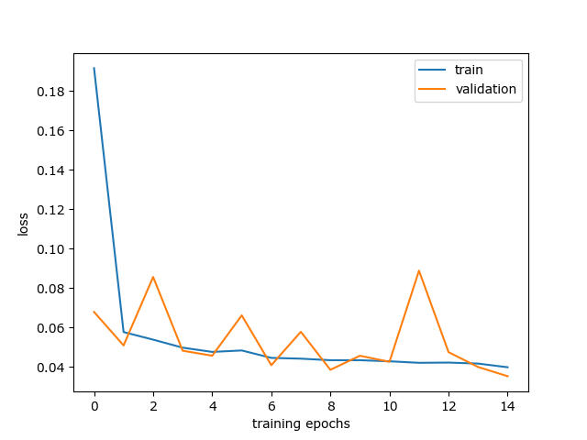
Figure 15 Training loss and Validation loss for LR = 0.01, Batch Size =128, Epochs = 15, with 70-20-10 Dataset split

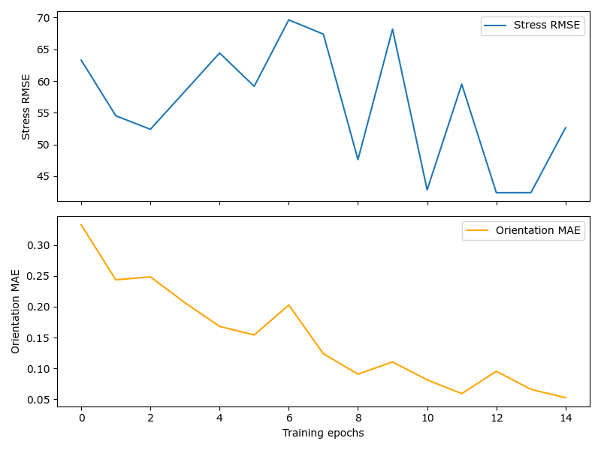
Figure 16 Stresses RMSE and Orientation MAE for LR = 0.01, Batch Size =128, Epochs = 15, 70-20-10 Dataset split

4.2.2 LR = 0.01, Batch Size = 128, Epochs = 30
Losses | Validation Dataset | Test Dataset
Total loss | 0.01137 | 0.01132
Stress RMSE | 35.3119 | 35.2667
Orientations MAE | 0.03416 | 0.03377
Table 5 Comparison between Validation and Test dataset Loss for LR = 0.01, Batch Size = 128, Epochs = 30, 70-20-10 Dataset split
The number of epochs were increased by 15 in this iteration. In Table 5, the validation and test total loss has decreased from 0.0254 to 0.01137. Stress RMSE has also decreased by 15 MPa, and the orientation MAE decreased from 0.05 to 0.034.
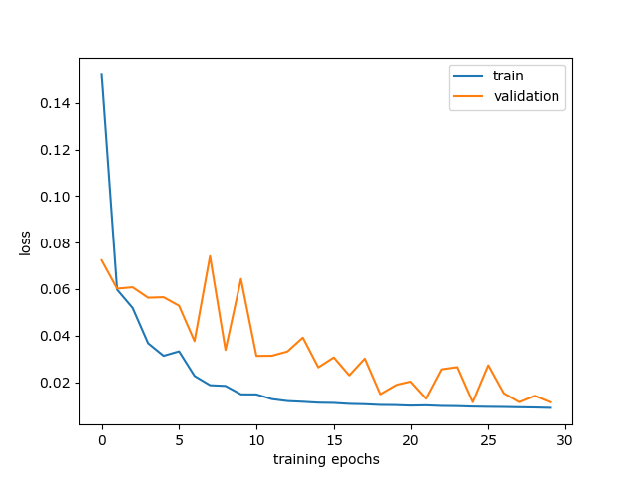
Figure 17 Training loss and Validation loss for LR = 0.01, Batch Size = 128, Epochs = 30, with 70-20-10 Dataset split
Figure 17 shows that the validation loss is decreasing and the spikes have decreased significantly. According to Figure 18, the stress RMSE and orientation MAE trend is converging and the spikes have decreased too. A smoother curve might be attained from more epochs. However, that is out of the scope of this study due to lack of computational resources.
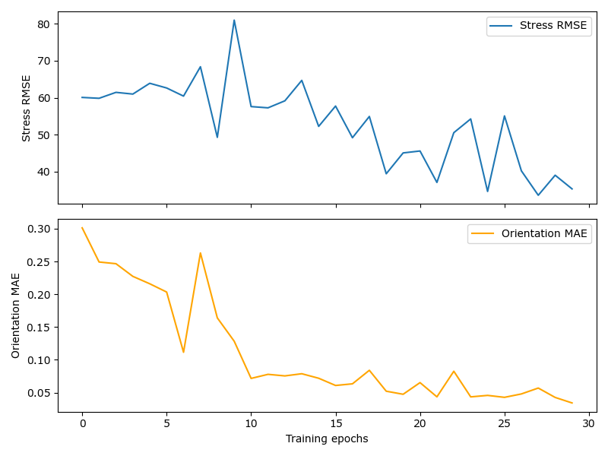
Figure 18 Stresses RMSE and Orientation MAE for LR = 0.01, Batch Size = 128, Epochs = 30, with 70-20-10 Dataset split

4.3 Addition of Max Pooling Layer
Max Pooling involves sliding a kernel, usually 2x2, over the output of a convolution block. This kernel returns the maximum value encountered by it; therefore, max pooling is used to down sample the network. This helps in increasing the speed of the network and reducing overfitting.
Max Pooling layers were added after the 2nd and 3rd convolution blocks and the results were recorded. Each max pooling layer had a filter of size 2x2 and a stride of 2. Additionally, 2 Convolution layers were replaced with Convolution Transpose layers that up sample the input back to 16x16x16.

4.3.1 Lr = 0.01, batch size =128, Number of epochs =30
Losses | Validation Dataset | Test Dataset
Total loss | 0.02694 | 0.02692
Stress RMSE | 36.1301 | 36.05341
Orientations MAE | 0.1678 | 0.1680
Table 6 Comparison between Validation and Test dataset Loss with Lr = 0.01, batch size =128, Number of epochs =30, 70-20-10 Dataset split with Max Pooling
Number of epochs were kept at 30 because lower number of epochs were not giving acceptable results. In this iteration, as shown in Table 6, validation and test total loss has increased from 0.011 to 0.0269 as compared to a similar model without max pooling. Stress RMSE is similar but, the orientation MAE has significantly increased.
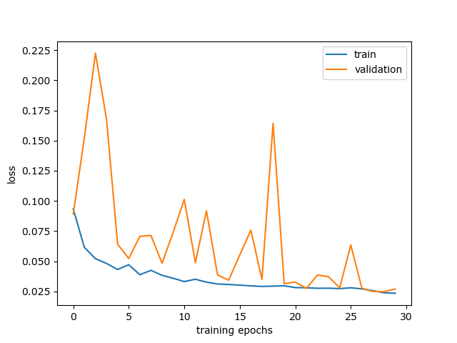
Figure 19 Training loss and Validation loss with Lr = 0.01, batch size =128, Number of epochs =25, with 70-20-10 Dataset split
Figure 17 shows that the validation loss is decreasing but the spikes have increased significantly. According to Figure 18, the stress RMSE and orientation MAE trend is converging but the spikes have increased.
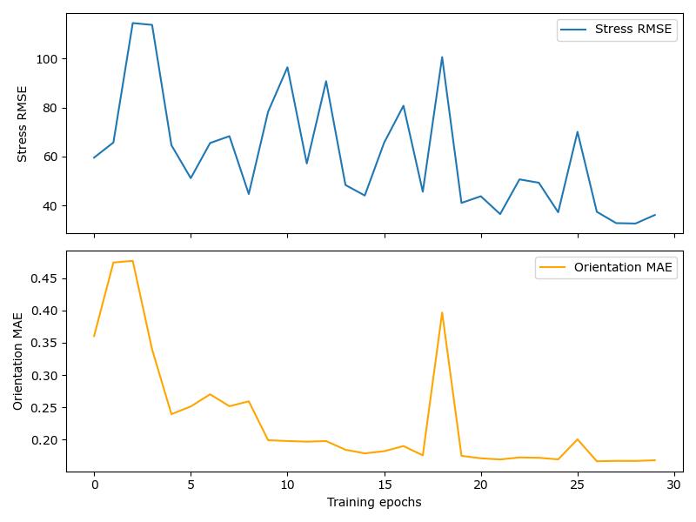
Figure 20 Stresses RMSE and Orientation MAE for Lr = 0.01, batch size =128, Number of epochs =25
It is evident the model is performing worse with max pooling layers. One of the reasons could be the fact that it reduces spatial information.

4.4 Addition of Dropout Layer
Dropout layer is added to the network to reduce overfitting. A dropout layer randomly removes some of the nodes from the training run to reduce the size of the data.
In the network, 6 dropout layers (with probability 0.2) were added, 1 after each convolution block except the last one.

4.4.1 Lr = 0.01, batch size =128, Number of epochs =15
Losses | Validation Dataset | Test Dataset
Total loss | 0.03524 | 0.0357
Stress RMSE | 55.1419 | 55.5518
Orientations MAE | 0.1315 | 0.1320
Table 7 Comparison between Validation and Test dataset Loss with Lr = 0.005, batch size =128, Number of epochs =15, 70-20-10 Dataset split
The number of epochs used were 15 to check how well the network generalises the data without consuming too much time. As shown in Table 7, both validation and test total loss have decreased significantly. The Stress RMSE also decreased by 10 MPa as compared to the previous model however, the Orientation MAE is still the same.
Figure 15 shows that the validation loss is decreasing, however it still has spikes. Figure 16 shows that Stress RMSE and Orientation MAE trend has not changed. This could be fixed by adding more epochs.
Figure 21 Training loss and Validation loss with Lr = 0.01, batch size =128, Number of epochs =15, with 70-20-10 Dataset split and Dropout Layer
Batch normalisation layers were not removed in this run. Since dropout and batch normalization layer together create Disharmony in the network, the next run was without batch normalization.

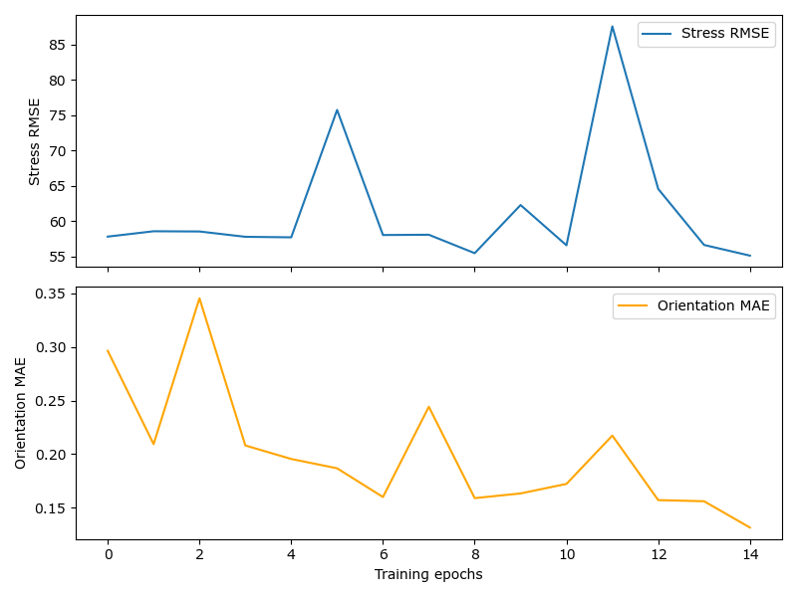
Figure 22 Stresses RMSE and Orientation MAE for Lr = 0.01, batch size =128, Number of epochs =15 and Dropout Layer

4.4.2 Lr = 0.01, batch size =128, Number of epochs =30
Losses | Validation Dataset | Test Dataset
Total loss | 0.09179 | 0.09228
Stress RMSE | 57.7654 | 58.2585
Orientations MAE | 0.3761 | 0.3764
Table 8 Comparison between Validation and Test dataset Loss with Lr = 0.005, batch size =128, Number of epochs =15, 70-20-10 Dataset split
This time batch normalization layers were removed and replaced with dropout layers while keeping all the other parameters same. This resulted in a sudden decrease in loss in first epoch after which the loss for validation, test, stress and orientation remained constant.
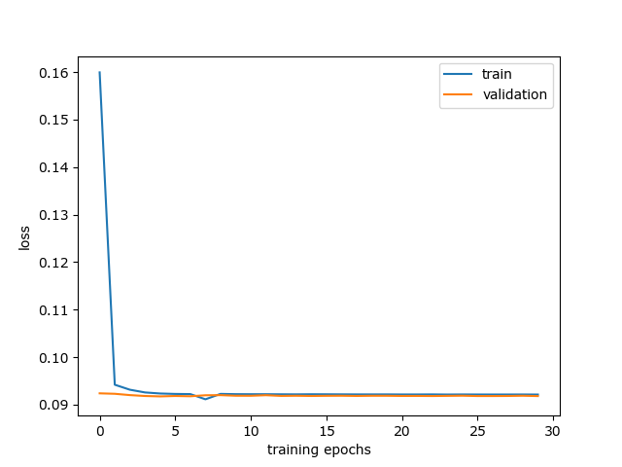
Figure 23 Training loss and Validation loss with Lr = 0.01, batch size =128, Number of epochs =30, with 70-20-10 Dataset split and Dropout Layer and no Batch normalization
Even though the trends appear improved, the test and validation loss have worsened as compared to the previous runs. Similarly, stress RMSE and orientation MAE have increased significantly.

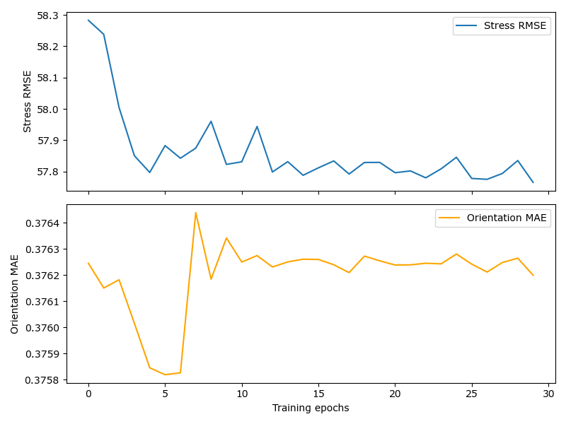
Figure 24 Stresses RMSE and Orientation MAE for Lr = 0.01, batch size =128, Number of epochs =30 and Dropout Layer and no Batch normalization

4.4 Final Model
After running the model at different hyperparameters and after addition and deletion of different layers like max pooling, dropout and batch normalisation, the model with the best performance was selected.
The number of dropping layers were reduced to 2 because 6 dropout layers were over regularizing the network. The learning rate was also decreased to 0.005 from 0.01 because large learning rate could have been resulting in large updates causing spiking. The train- validation-test data split was also changed from 70%-20%-10% to 65%-25%-10% because the validation dataset was suspected to be too small as compared to the training dataset.

Losses | Validation Dataset | Test Dataset
Total loss | 0.02309 | 0.0229
Stress RMSE | 31.4020 | 31.2148
Orientations MAE | 0.1612 | 0.1610
Table 9 Comparison between Validation and Test dataset Loss with Lr = 0.005, batch size =128, Number of epochs =30, 65-15-10 Dataset split
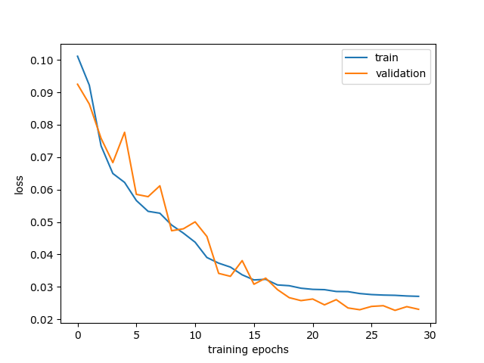
Figure 25 Training loss and Validation loss with Lr = 0.005, batch size =128, Number of epochs =30, with 65-25-10 Data split, 2 drop out layers and 2 max pooling layers
The model is generalising well on the data as shown by Table 9. The validation loss and test loss has decreased to 0.02309 and 0.02294. The stress RMSE has also significantly decreased to 31MPa and orientation MAE is also at an acceptable value of 0.161.

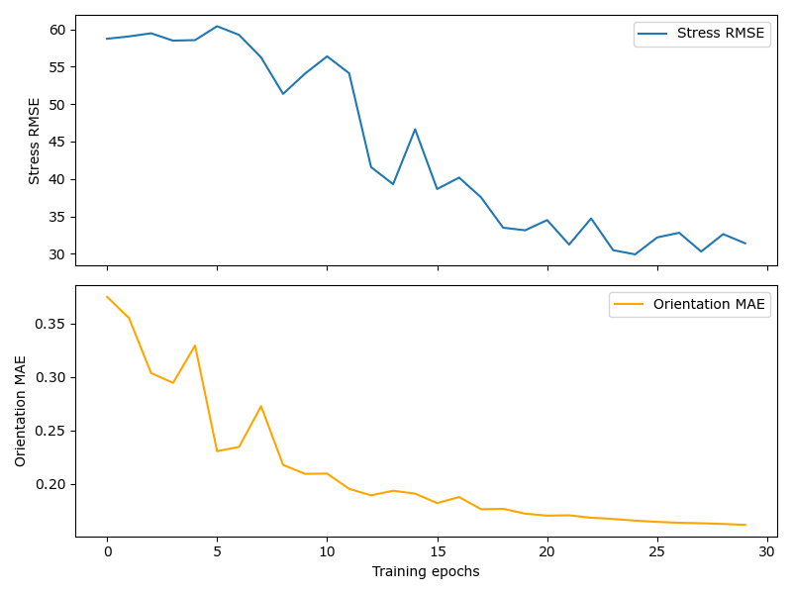
Figure 26 Stresses RMSE and Orientation MAE for Lr = 0.005, batch size =128, Number of epochs =30 with 65-25-10 Data split, 2 drop out layers and 2 max pooling layers
Both training loss and validation loss are converging and the spikes have also reduced. Similarly, stress RMSE is also decreasing with fewer and small spikes and orientation MAE has stabilised after 20 epochs.

4.5 Discussion
The experiment involved testing different NN architecture variants and tuning the hyperparameters of the network to obtain parameters that runs the network at best performance. Initially the dataset was split into 80% train data, 10% test data and 10% validation data. The model was evaluated at different hyperparameters using this data split. However, the loss was high and the network was not generalizing well on the data. The size of validation dataset was found to be too small, because of which the dataset split was changed from 80-10-10 to 70-20-10.
The model was then run again by tweaking the learning rate, epochs and addition of layers. The network performed better but there were still spikes in the loss which indicated that the network was not stable. The model seemed to be overfitting the data. To counter this, 2 max pooling layers (2x2, stride =2) were added but this led to a worse accuracy. This could be due to the lower spatial resolution caused by max pooling.
Assuming that the model was still overfitting the dataset, 6 dropout layers with a 20% probability were was added with no batch normalization. This led to a sudden decrease in loss in first epoch after which there were no changes in loss. The trends appeared good however, the loss had not decreased and the model had stopped training on the data after the first epoch.
The performance of the model worsened when max pooling and dropout layers were added. This could happen if the model was underfitting the data. This led to the conclusion that initially the model was overfitting the data and after the addition of dropout and max pooling layers, the model was underfitting the data.
To fix this issue, the number of dropout layers were decreased to 2, the learning rate was decreased to 0.005 and the data split was changed from 70-20-10 to 65-25-10 to increase the size of the validation dataset.
The reduction of regularization layers improved the network and the final model generalised well on the data and produced 2% training and validation loss, with 31 MPa RMSE in stress and 16% MAE loss in orientation. These results are comparable to the stress predictions in a similar approach using CNNs in the cited study. (14)

5 Conclusions
The goal of this paper was to implement Crystal Plasticity through a Neural Network. The training Data for the Neural network was obtained from DAMASK after running Crystal Plasticity simulations on 50 grain AA5083 RVE. Convolutional Neural Network was chosen for this task because it can capture features of the dataset while also maintaining the spatial information about the features.
The network was run at different hyperparameters and changes had to be made in the data split to achieve an acceptable performance. The Network replicated the Crystal Plasticity simulation information with 2% loss training and validation loss and 31 MPa stress RMSE and 16% orientation MAE which is an acceptable result. The losses could have been lowered if the model had run for more epochs.
Improvements in the model can be done by adding more convolutional layers. A larger dataset and higher number of epochs would also improve the performance of the network. These were not possible in this experiment due to time and computational constraints.
Future enhancements that can be done to simulate Crystal Plasticity better can include the utilization of different CNN architectures such as ResNet or U-Net. This, work do not explore the sequential nature of the simulations. For this, transformers and RNNs can be used as alternate ways of encoding the data.

List of Figures

Figure 1 Schematic of a Polycrystalline metallic material. The grain boundaries act as interface between grains. The movement of grains cause vacancies and atomic defects. Adapted from Microstructure and Properties of Engineering Materials Helmut Clemens, SveaMayer, and Christina Scheu. 2
Figure 2 Finite Deformation Kinematics adapted from Microstructure and Properties of Engineering Materials Helmut Clemens, SveaMayer, and Christina Scheu. 3
Figure 3 Lattice rotation in a single crystal tensile specimen adapted from Microstructure and Properties of Engineering Materials Helmut Clemens, SveaMayer, and Christina Scheu. 5
Figure 4 Plastic shear strain on a slip system adapted from Microstructure and Properties of Engineering Materials Helmut Clemens, SveaMayer, and Christina Scheu. 6
Figure 5 Kinematics of deformation of crystal adapted from Microstructure and Properties of Engineering Materials Helmut Clemens, SveaMayer, and Christina Scheu. 6
Figure 6 Kinematics of Crystal Deformation, Stretching and Spinning adapted from Microstructure and Properties of Engineering Materials Helmut Clemens, SveaMayer, and Christina Scheu. 8
Figure 7 Architecture of Typical DNN adapted from https://www.sciencedirect.com/science/article/pii/S004578252030637X 13
Figure 8 Architecture of AlexNet, used for image recognition and classification adapted from https://papers.nips.cc/paper_files/paper/2012/hash/c399862d3b9d6b76c8436e924a68c45b-Abstract.html 14
Figure 9 Training loss and Validation loss for LR = 0.01, Batch Size = 128, Epochs = 10 20
Figure 10 Stresses RMSE and Orientation MAE for LR = 0.01, Batch Size = 128, Epochs = 10 21
Figure 11 Training loss and Validation loss for LR = 0.005, Batch Size = 128, Epochs = 10 21
Figure 12 Stresses RMSE and Orientation MAE for LR = 0.005, Batch Size = 128, Epochs = 10 22
Figure 13 Training loss and Validation loss for LR = 0.01, Batch Size = 128, Epochs = 20 22
Figure 14 Stresses RMSE and Orientation MAE for LR = 0.01, Batch Size = 128, Epochs = 20 23
Figure 15 Training loss and Validation loss for LR = 0.01, Batch Size =128, Epochs = 15, with 70-20-10 Dataset split 24
Figure 16 Stresses RMSE and Orientation MAE for LR = 0.01, Batch Size =128, Epochs = 15, 70-20-10 Dataset split 24
Figure 17 Training loss and Validation loss for LR = 0.01, Batch Size = 128, Epochs = 30, with 70-20-10 Dataset split 25
Figure 18 Stresses RMSE and Orientation MAE for LR = 0.01, Batch Size = 128, Epochs = 30, with 70-20-10 Dataset split 25
Figure 19 Training loss and Validation loss with Lr = 0.01, batch size =128, Number of epochs =25, with 70-20-10 Dataset split 26
Figure 20 Stresses RMSE and Orientation MAE for Lr = 0.01, batch size =128, Number of epochs =25 26
Figure 21 Training loss and Validation loss with Lr = 0.01, batch size =128, Number of epochs =15, with 70-20-10 Dataset split and Dropout Layer 27
Figure 22 Stresses RMSE and Orientation MAE for Lr = 0.01, batch size =128, Number of epochs =15 and Dropout Layer 28
Figure 23 Training loss and Validation loss with Lr = 0.01, batch size =128, Number of epochs =30, with 70-20-10 Dataset split and Dropout Layer and no Batch normalization 28
Figure 24 Stresses RMSE and Orientation MAE for Lr = 0.01, batch size =128, Number of epochs =30 and Dropout Layer and no Batch normalization 29
Figure 25 Training loss and Validation loss with Lr = 0.005, batch size =128, Number of epochs =30, with 65-25-10 Data split, 2 drop out layers and 2 max pooling layers 29
Figure 26 Stresses RMSE and Orientation MAE for Lr = 0.005, batch size =128, Number of epochs =30 with 65-25-10 Data split, 2 drop out layers and 2 max pooling layers 30

References
1. Javier Segurado, et al. Advances in Applied Mechanics. 2018.
2. Mouritz, Adrian P. Introduction to Aerospace Materials . 2012.
3. Deformation of Single Crystals, Polycrystalline Materials, and Thin Films: A Review. Park, Guijun Yang and Soo-Jin. 2019, Materials (Basel).
4. Materials, Micromechanics of Composite. Jacob Aboudi, Steven M. Arnold and Brett A. Bednarcyk. 2013.
5. Böhm, Helmut J. Mechanics of Microstructured Materials. s.l. : Springer, 2004.
6. Crystal-plasticity finite-element analysis of anisotropic deformation behavior in a commercially pure titanium Grade 1 sheet. Takayuki Hama, Akihiro Kobuki, Hirohiko Takuda. s.l. : International Journal of Plasticity, 2017.
7. Study of Anisotropic Plastic Behavior in High Pressure Torsion of Aluminum Single Crystal by Crystal Plasticity Finite Element Method. Peitang Wei, Cheng Lu, Huaiju Liu, Lihong Su, Guanyu Deng and Kiet Tieu. s.l. : Crystals, 2017.
8. Crystal Plasticity Analysis Using Fast Fourier Transform Numerical Scheme. BACROIX, Takayuki OTSUKA Renald BRENNER Brigitte. 2018.
9. Multiscale crystal plasticity finite element model for investigating the irradiation hardening and defect evolution mechanism of A508-3 steel. Pandong Lin, Junfeng Nie, Meidan Liu. s.l. : Nuclear Materials and Energy, 2022.
10. Hybrid Micro-Macro-Modeling of Evolving Anisotropies and Length Scales in Finite Plasticity of Polycrystals. Ilona Frankenreiter, Daniele Rosato, Christian Miehe. 2011.
11. Machine learning: Trends, perspectives, and prospects. M. I. Jordan, T. M. Mitchell. 2015.
12. Deep learning. LeCun, Y., Bengio, Y. & Hinton, G. 2015.
13. Courville, Ian Goodfellow and Yoshua Bengio and Aaron. Deep Learning. 2016.
14. A convolutional neural network based crystal plasticity finite element framework to predict localised deformation in metals. Ibragimova, O., Brahme, A., Muhammad, W., Connolly, D., Lévesque, J., & Inal, K. 2022.
15. Deep residual learning for image recognition. He, K., Zhang, X., Ren, S., & Sun, J. 2016.
16. U-net and its variants for medical image segmentation: A review of theory and applications. Siddique, N., Paheding, S., Elkin, C. P., & Devabhaktuni, V. 2021.
17. Incipience of Plastic Flow in Aluminum with Nanopores: Molecular Dynamics and Machine-Learning-Based Description. Alexander E. Mayer, Polina N. Mayer, Mikhail V. Lekanov, Boris A. Panchenko. 2022.
18. Graph Neural Network Modeling of Grain-scale Anisotropic Elastic Behavior using Simulated and Measured Microscale Data. Darren C. Pagan, Calvin R. Pash, Austin R. Benson, Matthew P. Kasemer. 2022.
19. Graph neural networks for an accurate and interpretable prediction of the properties of polycrystalline materials. Minyi Dai, Mehmet F Demirel, Yingyu Liang, Jia-Mian Hu. 2021.
20. Roters, F., Diehl, M., Shanthraj, P., Eisenlohr, P., Reuber, C., Wong, S. DAMASK–The Düsseldorf Advanced Material Simulation Kit for modeling multi-physics crystal plasticity, thermal, and damage phenomena from the single crystal up to the component scale. Roters, F., Diehl, M., Shanthraj, P., Eisenlohr, P., Reuber, C., Wong, S. L., ... & Raabe, D. 2019.
21. Adam: A Method for Stochastic Optimization. Diederik P. Kingma, Jimmy Ba. s.l. : Cornell University, 2014.

